**Design Document**

**“Only Flights”**



Project Members & Student Numbers:

* Kaloyan Andreev (4408020)
* Francisco Marcó (4467752)
* Sava Vasilev (4663438)

Elaboration Date: 10/10/2022

Table of content

1. Design details 2

2. Resource providers 5

3. Future work 6

4. C4 Model diagram 7

6.1. System context 7

6.2. Container diagram 7

5. UML Diagram 8

6. ERD Diagram 9

7. Use case diagram 10

# Design details

The project named “Only Flights” will be situated in two environments – the major part will be in Amazon Web Services where most of the stuff will take place while the of-site backup will be hosted on a separate server provided by Fontys Hogeschool.

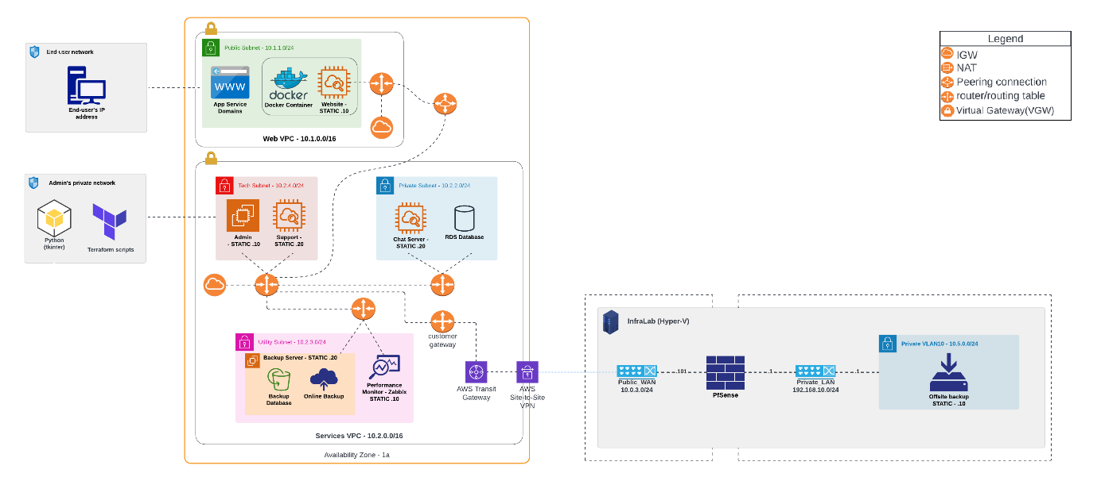The cloud environment will consist of five subnets – one public, which will be accessed be the end-users and four privates, where the backend services and transit VPN will be stored. Those subnets will be divided into three Virtual Private Clouds (VPCs) according to their role in the cloud. Each subnet will be attached to a router so, the traffic can be regulated easier. In the three VPCs will be placed an Internet Gateway (IGW) so, the instances inside can access the internet. To establish connection between the Virtual Private Clouds a Peering Connection (PCX) will be placed. Virtual gateway (VGW) will be implemented in Services VPC to make connection to the on-premises server. CloudWatch dashboards will be made to monitor several metrics of some of the most active servers. Lambda functions that will turn off and on some of the components will be also included.

On-premises server will contain a PfSense Firewall which will be attached to two virtual switches – one to access the public environment (WAN) and another to access the private environment (LAN). In the LAN side there will be a private virtual LAN (VLAN10), where the off-site backup will be placed.

Both infrastructures will be connected to each other by using site-to-site VPN connection.

In the front-end subnet, there will be placed the main feature of the project – a server on which will be hosted a flask website. The website will have several pages – login / sign up page, where the users must insert their credentials or to generate new once; home page from which fights tickets can be booked; account page that shows information about the user and history of previously made flights. Before using the website, the clients must be registered in the company’s database. After that process, they will be able to book flight tickets for every part of the world.

As it was mentioned earlier in the document, there will be three private subnets. The first one of them will contains the RDS SQL Server Database, where all information about the company’s customers such as personal and account details will be stored. The database will be configured in way that it will be available in multiple availability zones and the data will be backed up one time per day – usually in the window from 2am to 3am. The backups will be saved for at least seven days before they will be removed. A read-replica of the database will be created as well. The other instance in this subnet will be a chat server. It will be connected to the website for those users who have questions or problems related to the booking process. To make the communication easier and faster, a special bot will be designed to answer to the most common questions. They will be implemented in its code. In case query of the user is not in the bot’s range, the question will be sent to the technical support of the company who will deal with the client.

The second private subnet will contain the service administration virtual machines. These are the administrator and tech support’s instances. The admin will have the permission the control, maintain and establish connection to each server while the support will take care only for the chat server and the monitoring of machines.

In the last subnet of Services virtual private cloud, there will be situated the main backup server as well as a Zabbix monitoring tool.

The Alteration subnet will contain a Cisco third party router through which the connection between the back-end services and the second virtual environment will be made.

# Resource providers

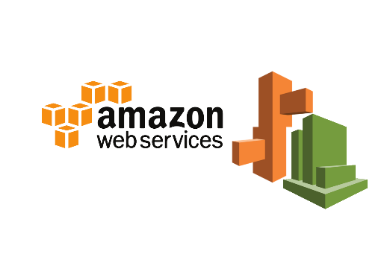During the development of the current project, resources from the following providers were used.

* ***Amazon Web Services***
* 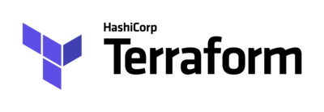***Terraform***
* 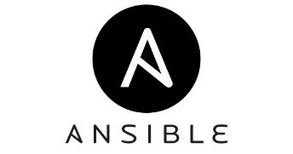***Ansible***
* 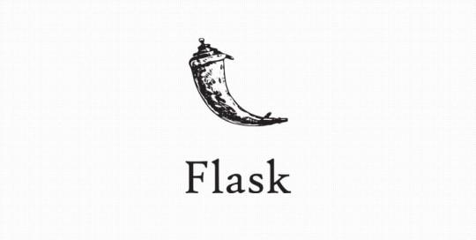***Flask***
* ***Zabbix***

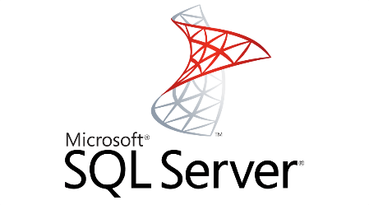

* ***Microsoft SQL Server***
* 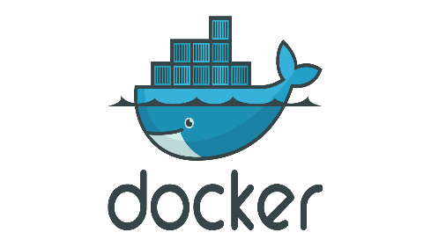***Docker***

# Future work

There is a plan in the future to distribute the whole system – cloud infrastructure, website and automation procedures, to as many as possible aircraft companies so, they could save time and financial resources and to have one secure and optimized platform that will be updated and maintained regularly.

# C4 Model diagram

## System context

## Diagrama Descripción generada automáticamenteContainer diagram

# UML Diagram

# Diagram Description automatically generatedERD Diagram

# Use case diagram